

Building Application Protocol

- Application for Building Permit is completed and delivered to the Building Inspector or the Municipal Office for the Building Inspector to pick up.

- Notification will be given from the Building Inspector that the application has been completed satisfactorily, and the applicant will then be given the amount of the Building/Sewage Permit fee.

- The Building Inspector will notify the Township Office of the amount of the fee(s), and the Office can then accept payment.

- Only after payment is received by the Township Office will the Building Inspector be notified.

- The building Inspector will contact the Applicant when building construction can commence.

MPAC notifies the municipality of all new assessments added to properties. Once this information is received by the municipality they will produce and mail a supplementary tax bill.

Application for a Permit to Construct or Demolish – Effective January 1, 2016

Township of Bonnechere Valley
49 Bonnechere Street West Eganville, ON K0J 1T0 Phone: 613-628-3101 Fax: 613-628-1336

BUILDING PERMIT APPLICATIONS

A building permit application and attached forms must be completed prior to obtaining a building permit. Building permit application packages are available at the Municipal Office for pickup or mail out.

PROCEDURE FOR OBTAINING A BUILDING PERMIT

- The building permit application is to be completed and delivered to the Building Inspector or left at the Municipal Office for pickup by the Building Inspector. Building permit requirements No. 1 to No. 7 that are outlined below must be met prior to submitting a completed building permit application.

Building Form B MUST be completed and MUST be dated and signed. (Refer to back of Form B for instructions and examples)

- Notification will be given from the Building Inspector that the application has been completed satisfactorily, and the applicant will then be given the amount of the building permit fee, sewage permit fee and lot development fee.

- The Building Inspector will notify the Municipal Office of the amount of the fee (s) owing by the applicant and they will accept payment of these.

- Only after payment is received by the Municipal Office will the Building Inspector be notified.

- The Building Inspector will contact the applicant when building/construction commence.

REQUIREMENTS FOR SECURING A BUILDING PERMIT

The following steps are required to be completed prior to the issuance of a building permit:

SOME OF THESE STEP’S MAY NOT BE NECESSARY FOR AN ACCESSORY BUILDING.

- DEED FOR YOUR PROPERTY
This must be shown to the Chief Building Official to establish your ownership of the property.

ENTRANCE PERMIT
Permission must be obtained by the road authorities for you to make an entrance from the road into your property. For residences, even if there is an existing entrance in place a permit is still required.
PRIVATE ROAD: Requires deeded access. Entrance Permit is not required.
TOWNSHIP ROAD: Contact Township Office 613-628-3101 x 2855 COUNTY ROAD: Contact the County of Renfrew
9 International Dr. Pembroke, ON K8A 6W5 613-732-4353

PROVINCIAL HIGHWAY: Contact the Ministry of Transportation 613-332-3220

PROPERTY IDENTIFICATION SIGNS (911)
PRIVATE ROAD: Contact Township Office 613-628-3101 x 226

TOWNSHIP ROAD: Contact Township Office 613-628-3101 x 2855, please note, an application will be made when obtaining your entrance permit

COUNTY ROAD: Contact Township Office 613-628-3101 x 2855

PROVINCIAL HIGHWAY: Contact Township Office 613-628-3101 x 2855

SEPTIC SYSTEM APPROVAL
Please contact Darryl Wagner, Chief Building Official and Sewage Inspector at 613-628-3101 Extension 242. Sewage systems must be approved before residential building permits are obtained. The fee for a standard sewage system is $500.00.

BLUEPRINT PLANS
Please contact Darryl Wagner, Chief Building Official and Sewage Inspector at 613-628-3101 Extension 242 or email at cbo@egamville.com for details.

ZONING BY-LAW CONFIRMATION
The proposed construction must conform to the Township’s Zoning By-Law where applicable.

LAND SURVEY AND/OR ELEVATION SURVEY
Certain circumstances (i.e. small lot, constructing close to setback limits etc.) may require a surveyor to establish the lot lines.

Application for a Permit to Construct or Demolish
❑
❑
❑
❑
❑
This form is authorized under subsection 8(1.1) of the Building Code Act.

For use by Principal Authority
Application number: |  |  |  |  | Permit number (if different):
Date received: |  |  |  |  | Roll number:
Application submitted to:
(Name of municipality, upper-tier municipality, board of health or conservation authority)
A. Project information
Building number, street name |  |  |  |  |  |  |  |  |  | Unit number |  |  | Lot/con.
Municipality |  |  | Postal code |  |  |  | Plan number/other description
Project value est. $ |  |  |  |  |  |  | Area of work (m²)
B. Purpose of application
New construction | Addition to an existing building |  |  | Alteration/repair |  |  |  |  | Demolition |  | Conditional Permit
Proposed use of building |  |  |  | Current use of building
Description of proposed work
C. Applicant Applicant is: |  | ❑ | Owner or |  |  | ❑ |  | Authorized agent of owner
Last name |  |  | First name |  |  |  | Corporation or partnership
Street address |  |  |  |  |  |  |  |  |  | Unit number |  | Lot/con.
Municipality |  |  | Postal code |  |  |  | Province |  |  | E-mail
Telephone number |  |  | Fax |  |  |  |  |  |  | Cell number
D. Owner (if different from applicant)
Last name |  |  | First name |  |  |  | Corporation or partnership
Street address |  |  |  |  |  |  |  |  |  | Unit number |  | Lot/con.
Municipality |  |  | Postal code |  |  |  | Province |  |  | E-mail
Telephone number |  |  | Fax |  |  |  |  |  |  | Cell number

❑
❑
❑
❑
❑
❑
❑
❑
❑
❑
❑
❑
❑
❑
E. Builder (optional)
Last name | First name | Corporation or partnership (if applicable)
Street address |  |  | Unit number |  | Lot/con.
Municipality | Postal code | Province | E-mail
Telephone number | Fax |  | Cell number
F. Tarion Warranty Corporation (Ontario New Home Warranty Program)
i. Is proposed construction for a new home as defined in the Ontario New Home Warranties Plan Act? If no, go to section G. |  |  |  | Yes |  | No
ii. Is registration required under the Ontario New Home Warranties Plan Act? |  |  |  | Yes |  | No
iii. If yes to (ii) provide registration number(s):
G. Required Schedules
- Attach Schedule 1 for each individual who reviews and takes responsibility for design activities.
- Attach Schedule 2 where application is to construct on-site, install or repair a sewage system.
H. Completeness and compliance with applicable law
i) This application meets all the requirements of clauses 1.3.1.3 (5) (a) to (d) of Division C of the Building Code (the application is made in the correct form and by the owner or authorized agent, all applicable fields have been completed on the application and required schedules, and all required schedules are submitted).  Payment has been made of all fees that are required, under the applicable by-law, resolution or regulation made under clause 7(1)(c) of the Building Code Act, I992, to be paid when the application is made. |  |  |  | Yes  Yes |  | No  No
ii) This application is accompanied by the plans and specifications prescribed by the applicable by-law, resolution or regulation made under clause 7(1)(b) of the Building Code Act, 1992. |  |  |  | Yes |  | No
iii) This application is accompanied by the information and documents prescribed by the applicable by-law, resolution or regulation made under clause 7(1)(b) of the Building Code Act, 1992 which enable the chief building official to determine whether the proposed building, construction or demolition will contravene any applicable law. |  |  |  | Yes |  | No
iv) The proposed building, construction or demolition will not contravene any applicable law. |  |  |  | Yes |  | No
I. Declaration of applicant
I declare that:
(print name)

- The information contained in this application, attached schedules, attached plans and specifications, and other attached documentation is true to the best of my knowledge.
- If the owner is a corporation or partnership, I have the authority to bind the corporation or partnership.
D

Date Signature of applicant
Personal information contained in this form and schedules is collected under the authority of subsection 8(1.1) of the Building Code Act, 1992, and will be used in the administration and enforcement of the Building Code Act, 1992. Questions about the collection of personal information may be addressed to: a) the Chief Building Official of the municipality or upper-tier municipality to which this application is being made, or, b) the inspector having the powers and duties of a chief building official in relation to sewage systems or plumbing for an upper-tier municipality, board of health or conservation authority to whom this application is made, or, c) Director, Building and Development Branch, Ministry of Municipal Affairs and Housing 777 Bay St., 2nd Floor. Toronto, M5G 2E5 (416) 585-6666.

Schedule 1: Designer Information
Use one form for each individual who reviews and takes responsibility for design activities with respect to the project.
❑
❑
❑
❑
❑
❑
❑
❑
❑
❑
❑
❑
A. Project Information
Building number, street name |  |  |  |  |  |  | Unit no. |  |  | Lot/con.
Municipality |  |  | Postal code |  |  | Plan number/ other description
B. Individual who reviews and takes responsibility for design activities
Name |  |  |  |  |  | Firm
Street address |  |  |  |  |  |  | Unit no. |  |  | Lot/con.
Municipality |  |  | Postal code |  |  | Province | E-mail
Telephone number |  |  | Fax number |  |  |  | Cell number
C. Design activities undertaken by individual identified in Section B. [Building Code Table 3.5.2.1. of Division C]
 |  | House |  |  | HVAC – House |  |  |  | Building Structural
 | Small Buildings Large Buildings Complex Buildings |  |  | Building Services  Detection, Lighting and Power Fire Protection |  |  |  | Plumbing – House Plumbing – All Buildings On-site Sewage Systems
Description of designer’s work
D. Declaration of Designer
I declare that (choose one as appropriate):
(print name)

I review and take responsibility for the design work on behalf of a firm registered under subsection 3.2.4. of Division C, of the Building Code. I am qualified, and the firm is registered in the appropriate classes/categories.
Individual BCIN: Firm BCIN:
I review and take responsibility for the design and am qualified in the appropriate category as an “other designer” under subsection 3.2.5. of Division C, of the Building Code.
Individual BCIN:
Basis for exemption from registration:

The design work is exempt from the registration and qualification requirements of the Building Code.
Basis for exemption from registration and qualification:
I certify that:
- The information contained in this schedule is true to the best of my knowledge.
- I have submitted this application with the knowledge and consent of the firm.

Date Signature of Designer
NOTE:
❑
❑
❑
- For the purposes of this form, “individual” means the “person” referred to in Clause 3.2.4.7(1) d).of Division C, Article 3.2.5.1. of Division C, and all other persons who are exempt from qualification under Subsections 3.2.4. and 3.2.5. of Division C.
- Schedule 1 is not required to be completed by a holder of a license, temporary license, or a certificate of practice, issued by the Ontario Association of Architects. Schedule 1 is also not required to be completed by a holder of a license to practise, a limited license to practise, or a certificate of authorization, issued by the Association of Professional Engineers of Ontario.

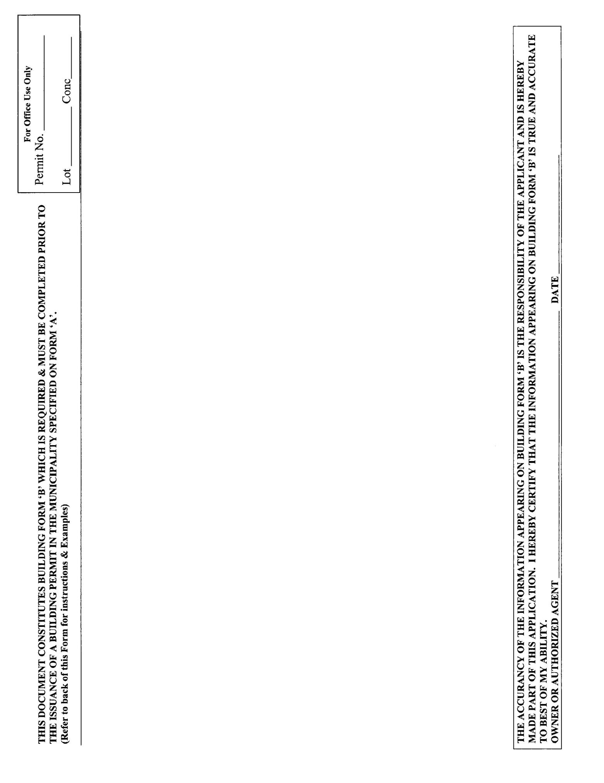

EXAMPLES ON.LY

SAMPLE TO USE FOR NEW BUILDING

SAMPLE toUSE FOR ADDITION TO BUILDING

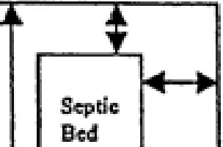
  - I,,
....
l'ilt
�-t- | -t--1 | :·-·········.,···· ...�  : Prcj>ofe(I • :  '"'.l: Building••.' · !

0 0
T
t
T
t
L L

[ l
Ii N
I ,:
N N

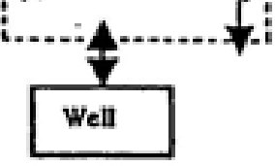
;

Name of Street/Road

'II/di

Name of Street/Road

SAMPLE to USE for ACCESSORY BUILDING

ITEMS THAT MUST APPEAR ON SAMPLE USED
1 Frontage of lot

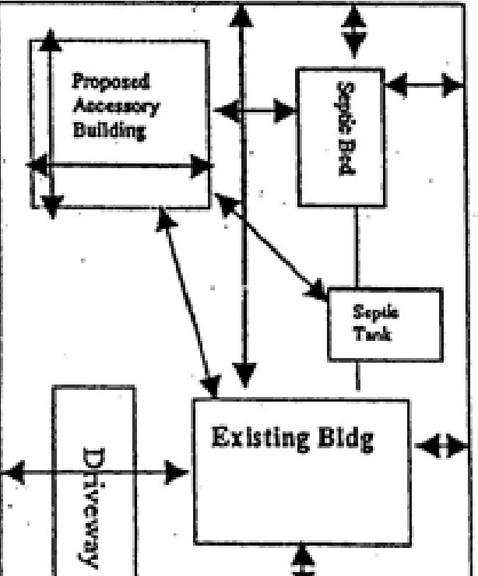
I .
L
,Q,
T,
t

L
·1
l'f
!!
N
:2 Depth of Lot
- If irregular shape - all dlmens1ons

- Location-of Septic System

- Location of Driveway

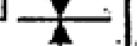
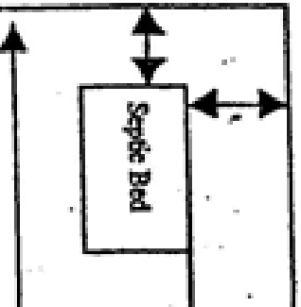
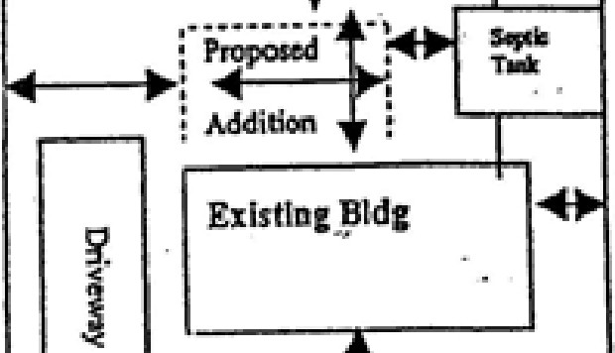


- North to be indicated

- Size of Proposed. Building or Addition

- Measurement In feet from, Proposed or Existing Buildings in Relation to all Lot tines and any water course (ie. creek.

stream, marsh, lake or river)
◄ ► 9 Don’t forget to sign Building
form B"

