Township
of
Bonnechere Valley

Emergency Management

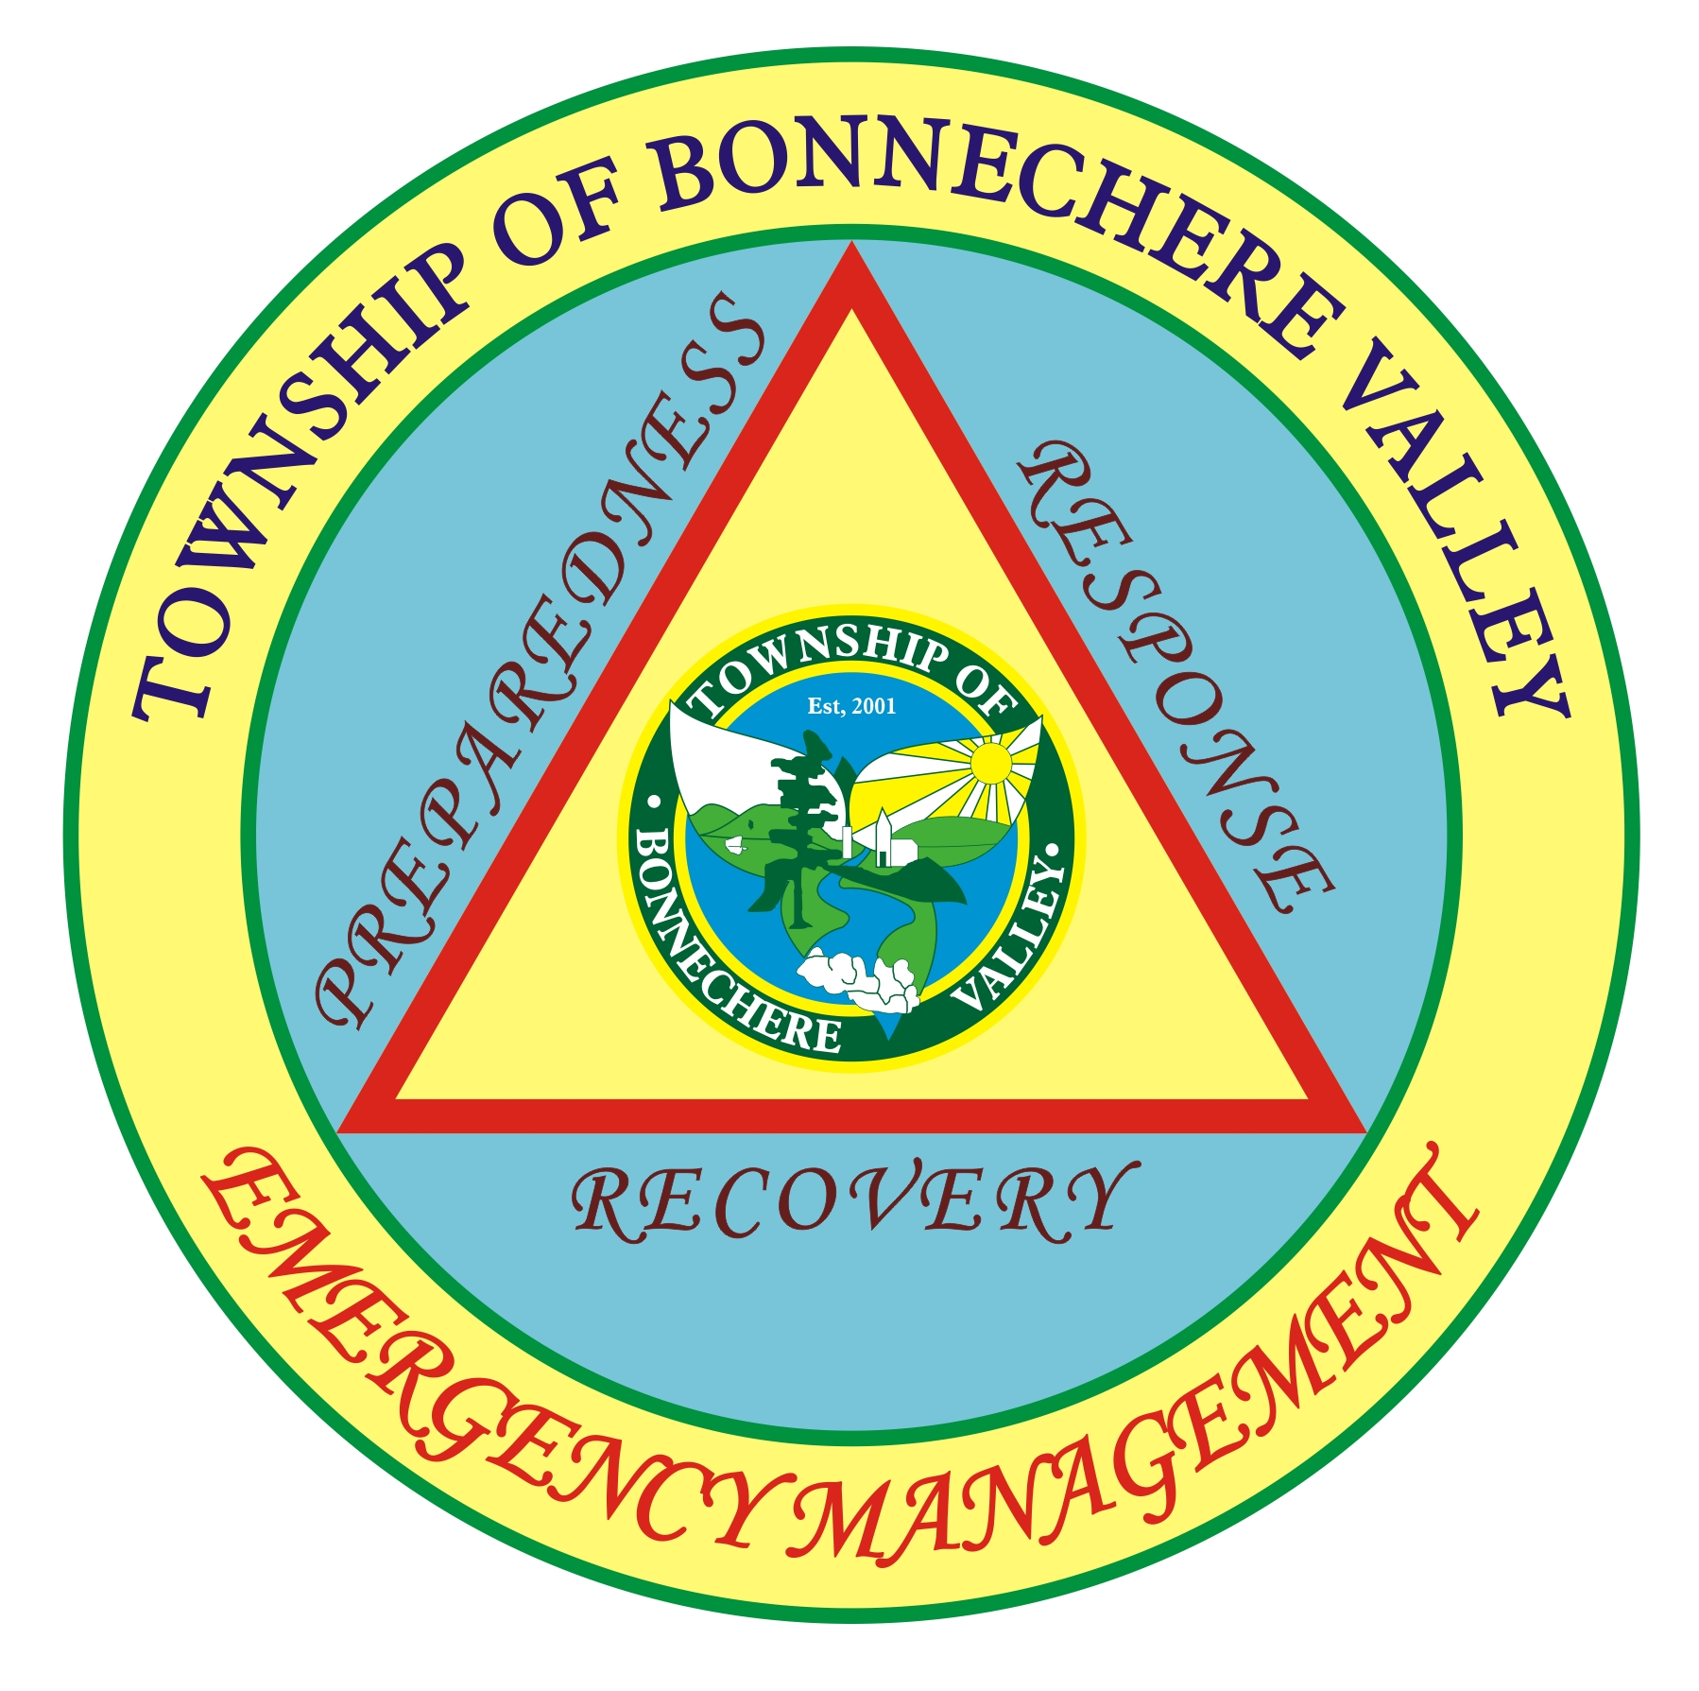

SEPTIC SYSTEMS

AFTER THE FLOOD
What to Do When Your Septic System Has Flooded

Do NOT use your sinks and toilets if the soil around your house and septic system is still waterlogged or flooded. Your septic system will not work under those conditions.
Contact a qualified septic system installer to have a professional evaluation of potential damage to your septic system from the flood and receding flood waters

How will I know if the flood damaged my septic system or my septic field?

Signs that your septic tank was damaged during flooding may include the following conditions:

- Settling or sinking of the soil around your septic tank or septic field
- Sudden holes appearing in the soil around your septic tank and field system, where there previously were none
- wastewater is not draining properly, such as water draining very slowly or not at all from the sinks, and toilets draining very slowly or making strange noises when you flush them
- If your septic field is clogged by silt, a new field system may have to be installed. Check with a qualified septic system installer
What should I do first?
- Check to see if all septic tank maintenance covers are still in place.
- Repair any damaged tank outlet covers, and replace any missing tank outlet covers immediately.
- Restrict the amount of water being used in your home to allow the water saturating the soil around your septic tank and field to dry out. Restrict your household water usage temporarily. Do not do laundry at home if possible (use a laundromat).
- Do not use the dishwasher or garbage disposal.
- Re-direct water from your roof downspouts away from the septic field.
- Reduce the number of daily showers or baths per household member.
- Do not have water from your basement sump pump going into the septic system.
- Contact the local municipal authority or a qualified septic system installer to have a professional evaluation of potential damage to your septic system from the flood and receding flood waters.

Is it a good idea for me to pump out my septic tank right away?

No. Do NOT pump out your septic tank when the soil around the tank or the drainage field is still saturated with water. This may cause the septic tank to float and break out of the ground,
damaging the tank inlet and outlet pipes.

How soon can I have my septic system worked on?
Wait until all of the soils around your septic tank and field are no longer saturated by flood water and are dry before you bring in contractors to work on your septic system.
Do NOT drive equipment or vehicles over your septic field. Wet soils compact more quickly, which will reduce the ability of your system to work properly in the future or may cause damage to the buried pipes of your septic field.
Do NOT set dumpsters or building materials on top of your septic field during clean-up and rebuilding; this will further damage your septic field.

When can I use my septic system again?
- Do NOT use your septic system until it has been checked to ensure it hasn’t been damaged by the flood.
- Do NOT use your septic system until the standing water in the septic field is lower than the water level around your house or buildings.
- Do NOT use your septic system until all electrical connections have been checked for damage (before restoring electricity to the pump).
- Do NOT use your septic system until the outlet tee on your tank has been checked for a blockage. The scum layer of fats/grease inside your septic tank may have floated to the top of the tank during the flooding, resulting in partial blockage of the outlet. This can result in a potential sewage backup into your house.
- Do NOT pump any floodwater inside your home into the sink or toilet. This can cause a higher volume of wastewater to enter your septic tank, and may result in pushing waste solids that should settle in the septic tank, to enter your septic field and clog the septic pipes in your septic field.



