TOWNSHIP
OF
BONNECHERE VALLEY

EMERGENCY MANAGEMENT

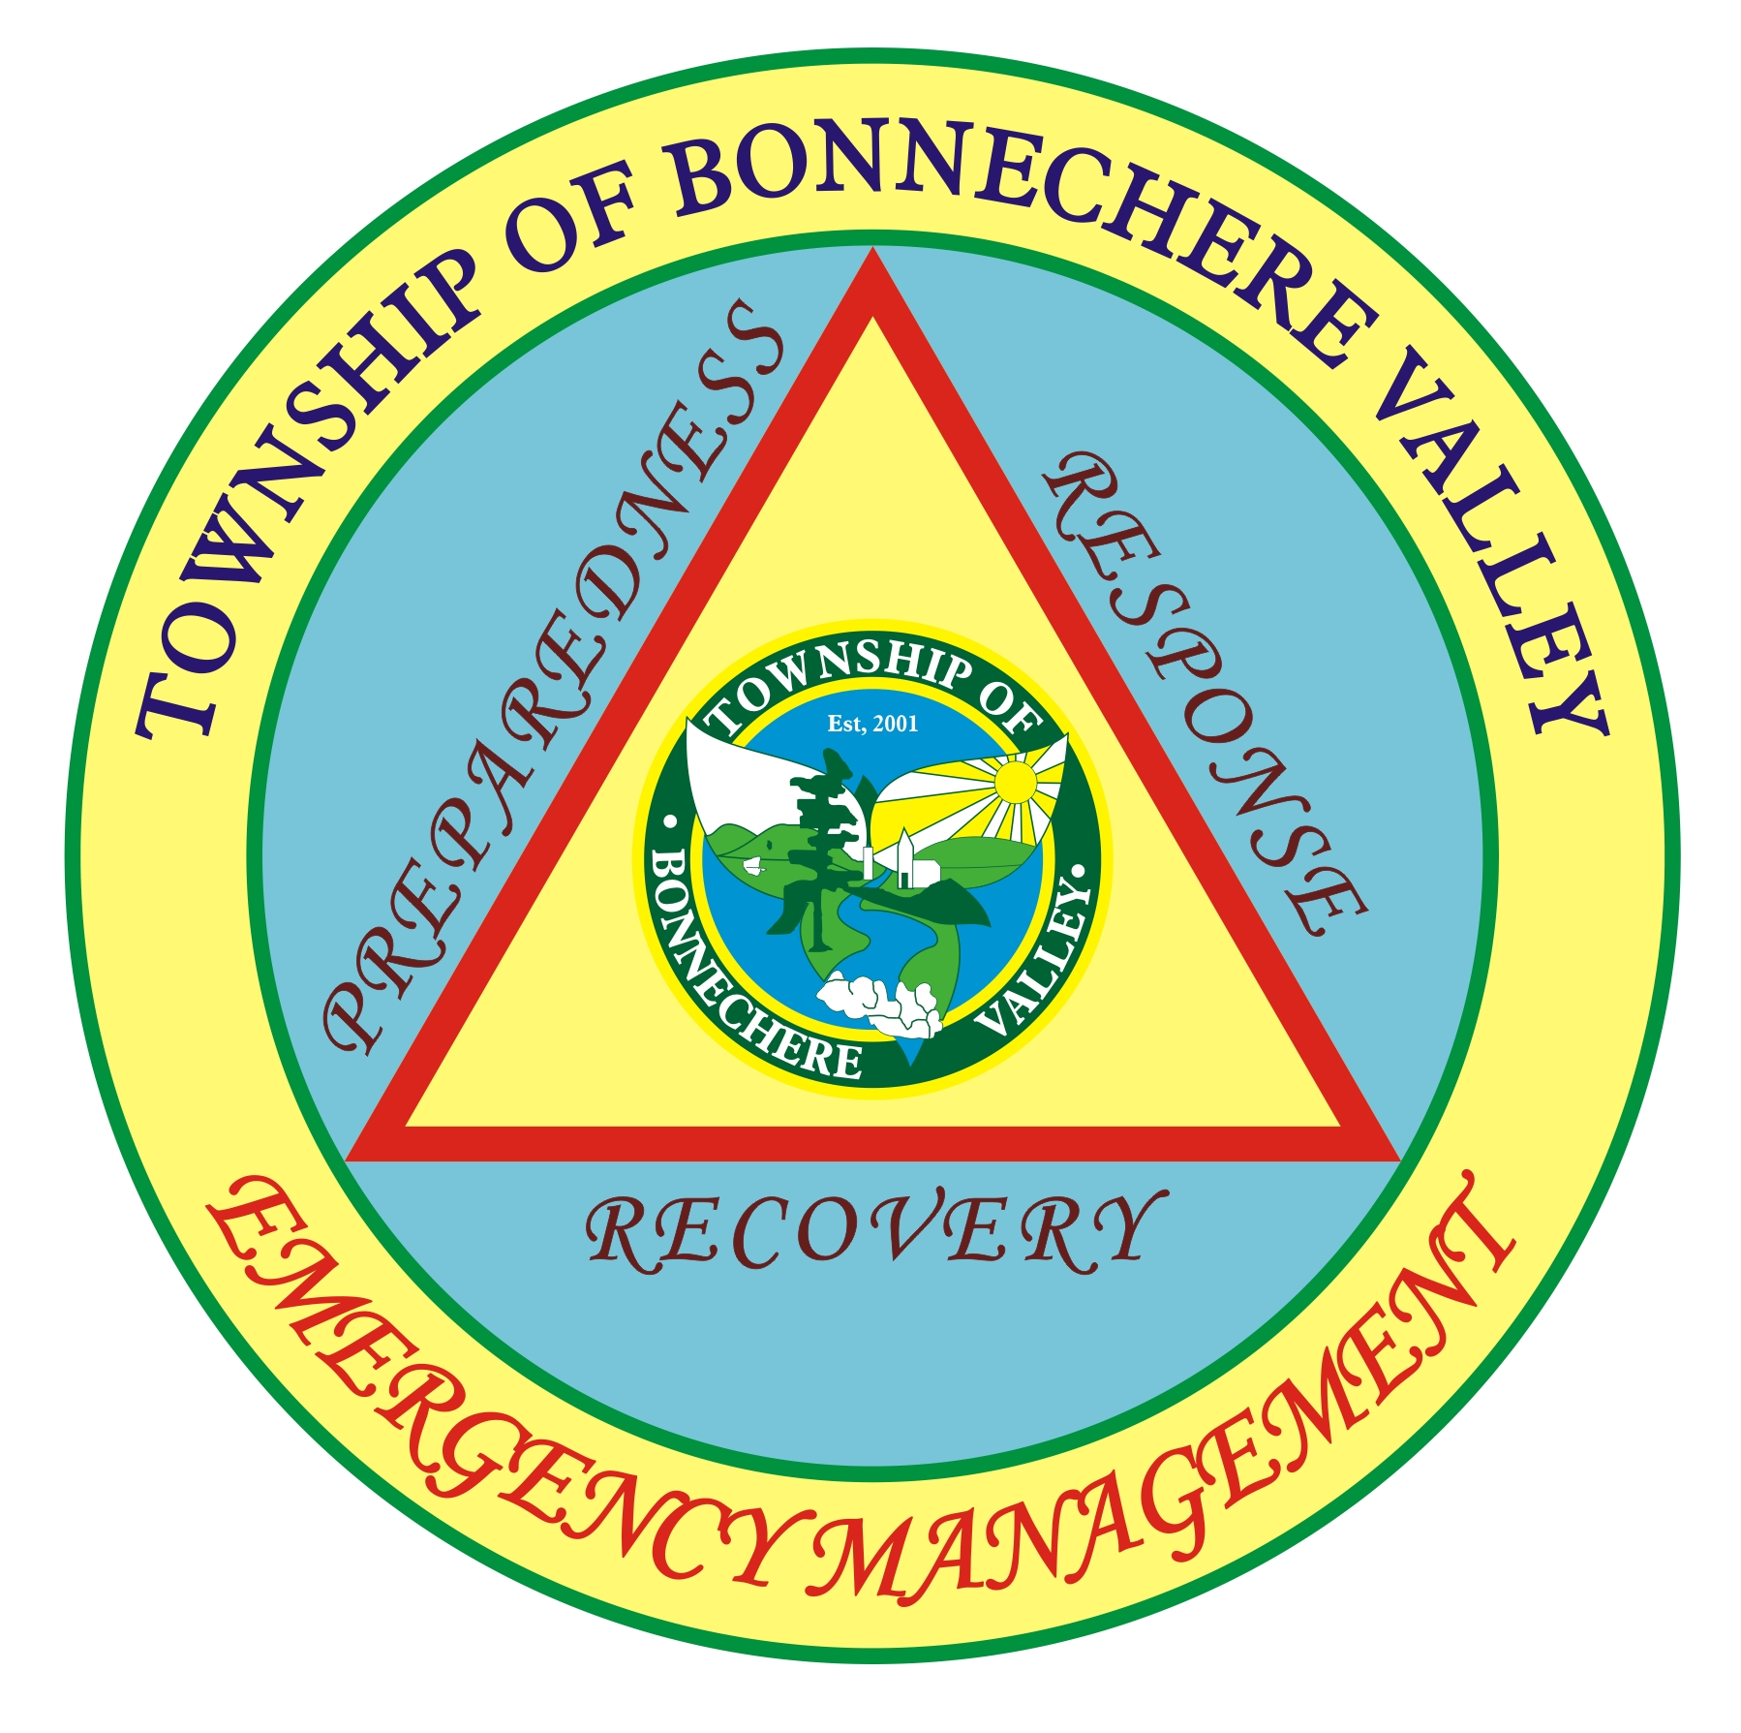

WELLS

WHAT TO DO AFTER THE FLOOD
What to Do After the Flood
Drilled, driven or bored wells are best disinfected by a well or pump contractor, because it is difficult for the private owner to thoroughly disinfect these wells.
WARNING!
DO NOT TURN ON THE PUMP
There is danger of electrical shock and
damage to your well or pump
if they have been flooded
If you suspect that your well may be contaminated, contact your local or health department for specific advice on disinfecting your well. The suggestions below are intended to supplement flood precautions issued by Provincial and local health authorities. | WARNING!  DO NOT WASH WITH WELL WATER  People drinking or washing with water  from a private well that has been flooded  will risk getting sick.

Well and Pump Inspection
Flood Conditions at the Well - Swiftly moving flood water can carry large debris that could loosen well hardware, dislodge well construction materials or distort casing. Coarse sediment in the flood waters could erode pump components. If the well is not tightly capped, sediment and flood water could enter the well and contaminate it. Wells that are more than 10 years old or less than 50 feet deep are likely to be contaminated, even if there is no apparent damage. Floods may cause some wells to collapse.
Electrical System - After flood waters have receded and the pump and electrical system have dried, do not turn on the equipment until the wiring system has been checked by a qualified electrician, well contractor, or pump contractor. If the pump’s control box was submerged during the flood all electrical components must be dry before electrical service can be restored. Get assistance in turning the pump on from a well or pump contractor.
Pump Operation - All pumps and their electrical components can be damaged by sediment and flood water. The pump including the valves and gears will need to be cleaned of silt and sand. If pumps are not cleaned and properly lubricated, they can burn out. Get assistance from a well or pump contractor who will be able to clean, repair or maintain different types of pumps.

Emergency Disinfection of wells that have been flooded

Step 1.
Materials Needed:
- One gallon of non-scented household liquid bleach;
- rubber gloves;
- eye protection;
- old clothes; and
- a funnel.

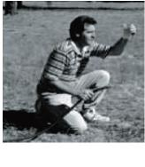
Before Disinfection: Check the condition of your well. Make sure there is no exposed or damaged wiring. If you notice any damage, call a professional before the disinfection process.

Step 2.

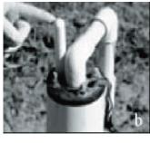
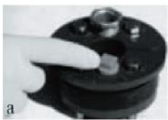
Determine what type of well you have and how to pour the bleach into the well. Some wells have a sanitary seal with either an air vent or a plug that can be removed (a). If it is a bored or dug well, the entire cover can be lifted off to provide a space for pouring the bleach into the well (b).

Step 3.

If your water is muddy or cloudy, run the water from an outside spigot with a hose attached until the water becomes clear and free of sediments.
Take the gallon of bleach and funnel (if needed) and carefully pour the bleach down into the well casing

Step 4

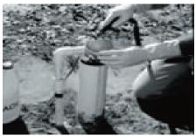
After the bleach has been added, run water from an outside hose into the well casing until you smell chlorine coming from the hose. Then turn off the outside hose.

Step 5
Turn on all cold-water faucets, inside and outside of house, until the chlorine odor is detected in each faucet, then shut them all off. If you have a water treatment system, switch it to bypass before turning on the indoor faucets.
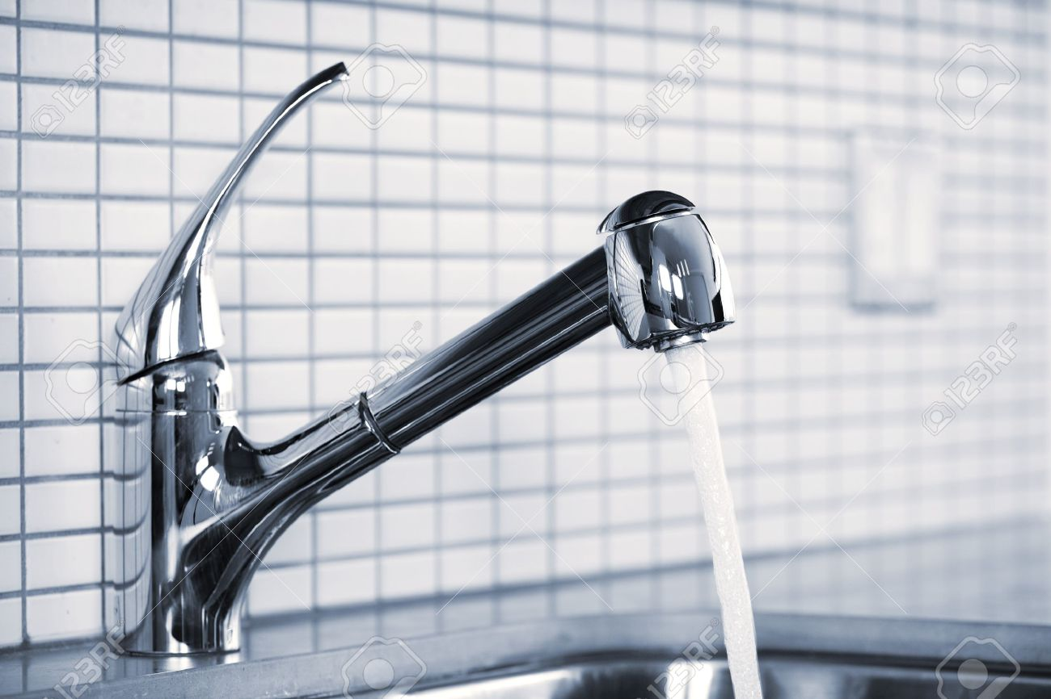

Step 6

Wait 6 to 24 hours before turning the faucets back on.
It is important not to drink, cook, bathe or wash with this water during the time period --- it contains high amounts of chlorine.

Step 7

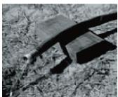
Once the waiting period is up, turn on an outside spigot with hose attached and run the water into a safe area where it will not disturb plants, lakes, streams or septic tanks. Run the water until there is no longer a chlorine odor. Turn the water off.

Step 8
The system should now be disinfected, and you can now use the water for showering, dishes and washing..

Step 9

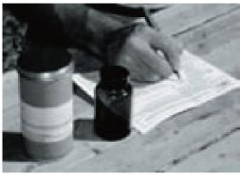
Have your water tested for bacteria 7 to 10 days after disinfection

CAUTION:

Because of the extensive flood area and the speed and direction of ground water flow, your well may not be a safe source of drinking water for many months after the flood.
The well can become contaminated with bacteria or other contaminants.
Wastewater from malfunctioning septic tanks or chemicals seeping into the ground can contaminate the ground water even after the water was tested and found to be safe.

It will be necessary to take long range precautions, including repeated testing, to protect the safety of drinking water.

Sampling and Testing the Well Water
Well water testing kits are available from the Municipal Office.
The health department issues sterile bottles for the private well owner to collect water samples, follow all instructions for the use of these bottles.
After the pump is back in operation, the health department should sample and test the water at regular intervals.

